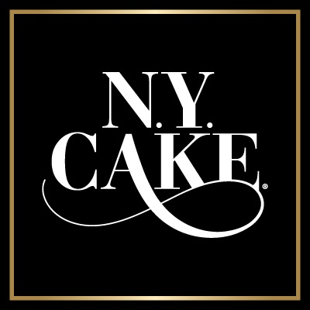
170 Ludlow Street
Yonkers, NY 10705
914-920-3119 Office
914-371-6973 Fax
nycakewholesale@gmail
www.newyorkcakesupplies.com

Wholesale account request.
Thank you for your interest in NY Cake (Universal Brands LLC) We pride ourselves in producing quality products and the finest cake decorating tools and fondant tools in the industry. If you ever have a question we always encourage our customers to call or email us. Customer service is our goal.
Please fill out the Wholesale Application form below. All pending accounts go through an approval process and must be accepted as a wholesale account before placing a wholesale order. Once approved we will send you all the wholesale information, Via e-mail or phone call.

*Please include Tax ID Certificate with application.
Please print clearly
Company Information
* Company Name:
* Tax ID Number:
Company Owner / Manager
* First Name:
* Last Name:
Shipping / Delivery
* Address:
Address 2:
* City:
* State:
* ZIP Code:
Billing Address
Address:
Address 2:
City:
State:
ZIP Code:
* Please check your type of business: Bakery Retail Store Website Teacher Caterer
Buyer Contact Information
* First Name:
* Last Name:
Phone:
Email:
FAX:
* Number of years in business?
Please email or fax a copy of your Tax id or business license along with completed form to nycakewholesale@gmail.com
Call: 914-920-3119
Fax: 914-371-6973
***** Please Note

Universal Brands LLC reserves the right to refuse service to any customer discounting the line of products purchased. This includes all lines of products manufactured and distributed including NY Cake line, James Rosselle line, Colette Peters as well as Lisa Mansour. They must be sold at suggested retail on all internet shopping sites such as ebay amazon, etc. They may NOT be discounted without prior consent.
I hereby agree not to discount any products online

X___________________________________________________________

